TALWIND CSS

1) CSS FRAMEWORK
2) ALMOST NO NEDD TO WRITE DIFFERENT CSS
3) A LOT OF CLASSES FOR STYLE
4) NO NEED TO OVERIDE CSS
5) FAST DEVLOPMENT
6) FAST PERFORMANCE

HERE FOR EACH STYLING THERE IS A CLASS

IT IS LIGHT WEIGHT(BECAUSE EXTRA CSS NOT INCLUDE IN BUILD ) AS COMPARE TO OTHER CSS

which css framework is better is depened upon requiremnt

SETUP OF TALWIND CSS
a) by cdn----> problem talwind intellisence not work here
b) by cli ---> here intellisence work (USE IT IN PRODUCTION)
etc

CORE PRINCIPAL OF TALWIND CSS IS :-> UTILITY FIRST PRINCIPLE (FOR EACH THING THERE IS A DIFFRENT CLASS)

SETUP TALWIND CSS WITH CLI

a) need nodejs and npm
b) install talwind css
c) run build for generate output file --> automatich generated, output file contain all the encoded values
d) make html file and write code
e) install talwid intellisence for auto suggestion

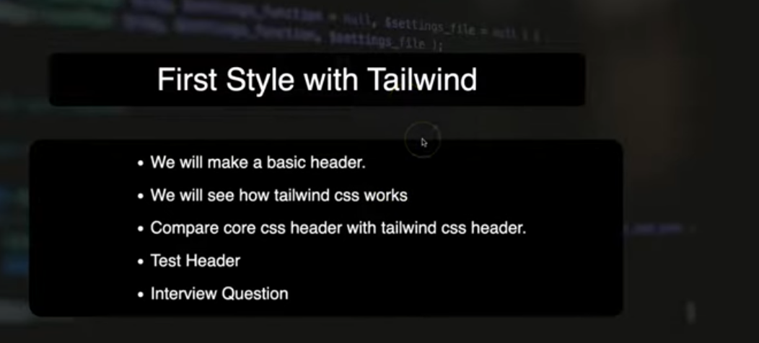

header.html

<!doctype html>
<html>
<head>
<meta charset="UTF-8">
<meta name="viewport" content="width=device-width, initial-scale=1.0">
<link href="./output.css" rel="stylesheet">
</head>
<body>

<div>

<ul class="bg-black text-white m-0 p-0 flex ">

<li class="flex"><a href="#" class="p-3 hover:bg-zinc-900">HOME</a></li>
<li class="flex"><a href="#" class="p-3 hover:bg-zinc-900">NEWS</a></li>
<li class="flex"><a href="#" class="p-3 hover:bg-zinc-900">CONTACT</a></li>
<li class="flex"><a href="#" class="p-3 hover:bg-zinc-900">ABOUT</a></li>

</ul>

</div>

</body>
</html>

now you see for each li i give flex so there is anyway to apply css in parent and all child will take it

[&>*]:flex
put this inside parent ul and it will apply on all of it’s child

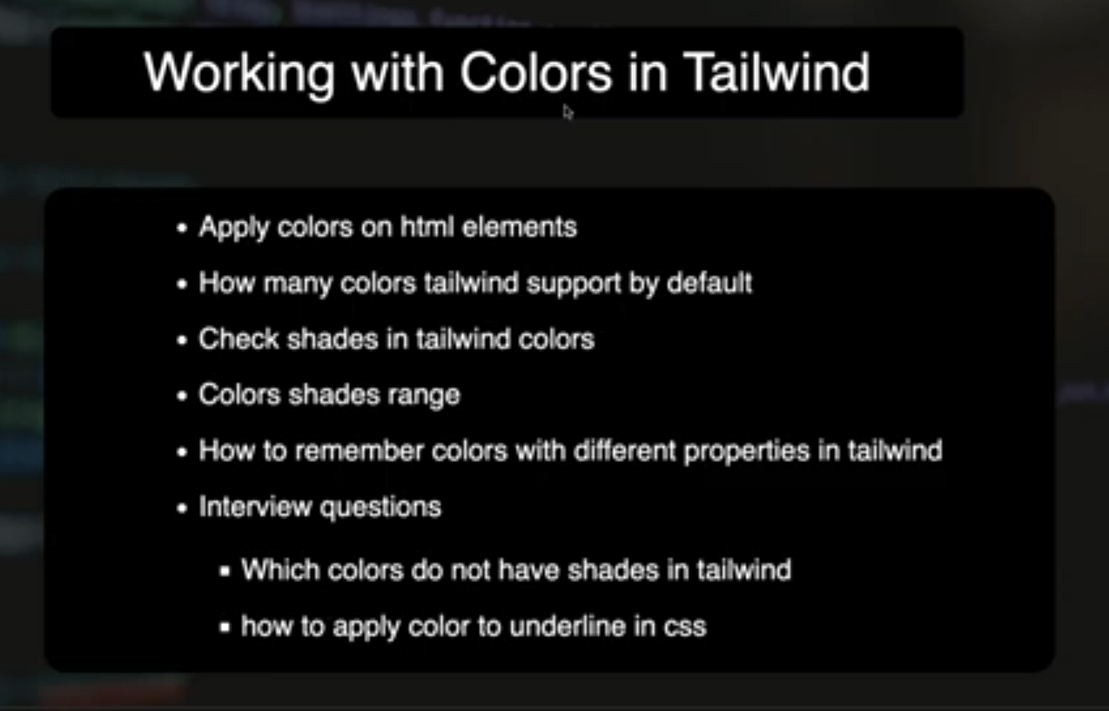
1) TEXT COLOR ---->

<p class="text-blue-100">learning talwind with code step by step </p>
<p class="text-blue-200">learning talwind with code step by step </p>
<p class="text-blue-300">learning talwind with code step by step </p>
<p class="text-blue-400">learning talwind with code step by step </p>
<p class="text-blue-500">learning talwind with code step by step </p>
<p class="text-blue-600">learning talwind with code step by step </p>
<p class="text-blue-700">learning talwind with code step by step </p>
<p class="text-blue-800">learning talwind with code step by step </p>
<p class="text-blue-900">learning talwind with code step by step </p>

2) BACKGROUND COLOR ---->

<p class="bg-red-100">learning talwind with code step by step </p>
<p class="bg-red-200">learning talwind with code step by step </p>
<p class="bg-red-300">learning talwind with code step by step </p>
<p class="bg-red-400">learning talwind with code step by step </p>
<p class="bg-red-500">learning talwind with code step by step </p>
<p class="bg-red-600">learning talwind with code step by step </p>
<p class="bg-red-700">learning talwind with code step by step </p>
<p class="bg-red-800">learning talwind with code step by step </p>
<p class="bg-red-900">learning talwind with code step by step </p>

3) BORDER ---->

<p class="border-green-50 border-4">learning talwind with code step by step </p>
<p class="border-green-100 border-4">learning talwind with code step by step </p>
<p class="border-green-300 border-4">learning talwind with code step by step </p>
<p class="border-green-500 border-4">learning talwind with code step by step </p>
<p class="border-green-700 border-4">learning talwind with code step by step </p>
<p class="border-green-900 border-4">learning talwind with code step by step </p>

4) OUTLINE --->

<p class="outline-green-50 outline-4">learning talwind with code step by step </p>
<p class="outline-green-100 outline-4">learning talwind with code step by step </p>
<p class="outline-green-300 outline-4">learning talwind with code step by step </p>
<p class="outline-green-500 outline-4">learning talwind with code step by step </p>
<p class="outline-green-700 outline-4">learning talwind with code step by step </p>
<p class="outline-green-900 outline-4">learning talwind with code step by step </p>

shades having range foe all this colors are 50 to 950 and black and white having no shade

<span class="bg-amber-500 ml-10 mt-10 pl-10 pt-10 block ">span with margin and padding </span>

span only work for left and right not for top and bottom for this we have to make it block

a) how to give padding of 1 px only .

<h2 class="bg-cyan-400 pt-[1px]">Heading</h2>

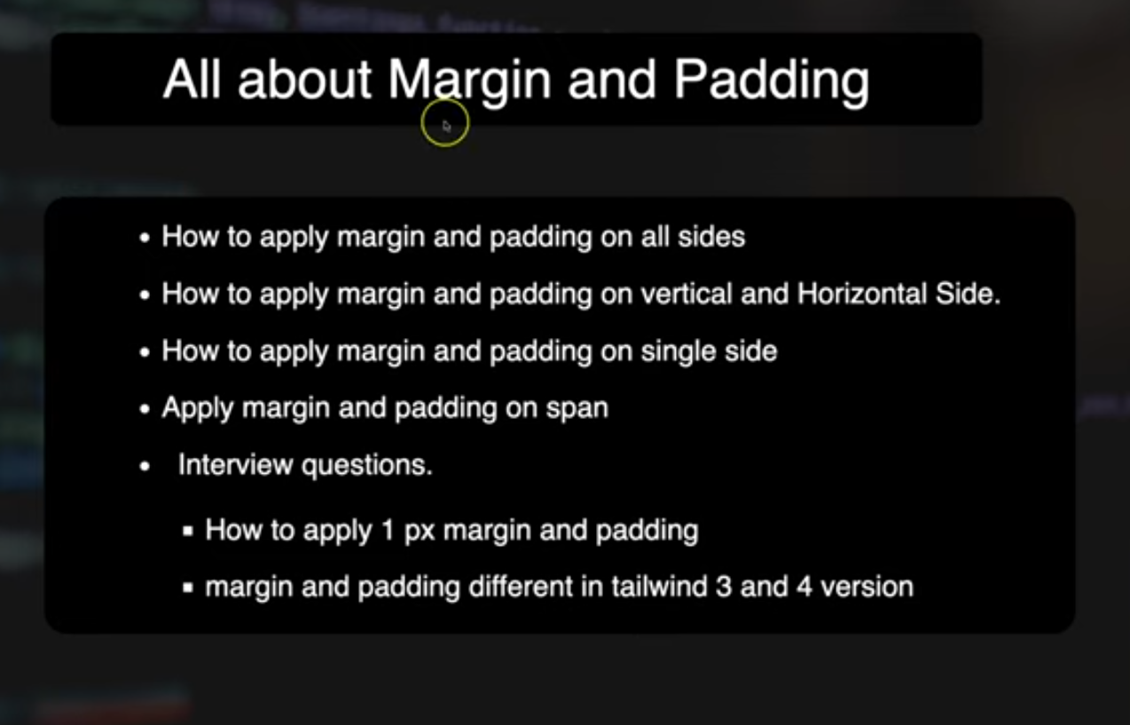

1)PADDING and MARGIN

in talwind 4 for margin and padding there is no issue of range 0 to 10000etc

a) margin and padding in all direction

<h1 class="bg-red-950 text-amber-50 p-10 m-2">heading</h1>

b) margin and padding left and right

<h1 class="bg-red-950 text-amber-900 px-10 mx-2">heading</h1>

c) margin and padding in top and bottom

<h1 class="bg-red-950 text-white-900 py-10 my-2">heading</h1>

d) padding and maring only on top ---> pt-10 mt-10
e) margin and padding only on bottom----> pb and mb
f) margin and padding only on left---> pl and ml
f) margin and padding only on right -->pr and mr

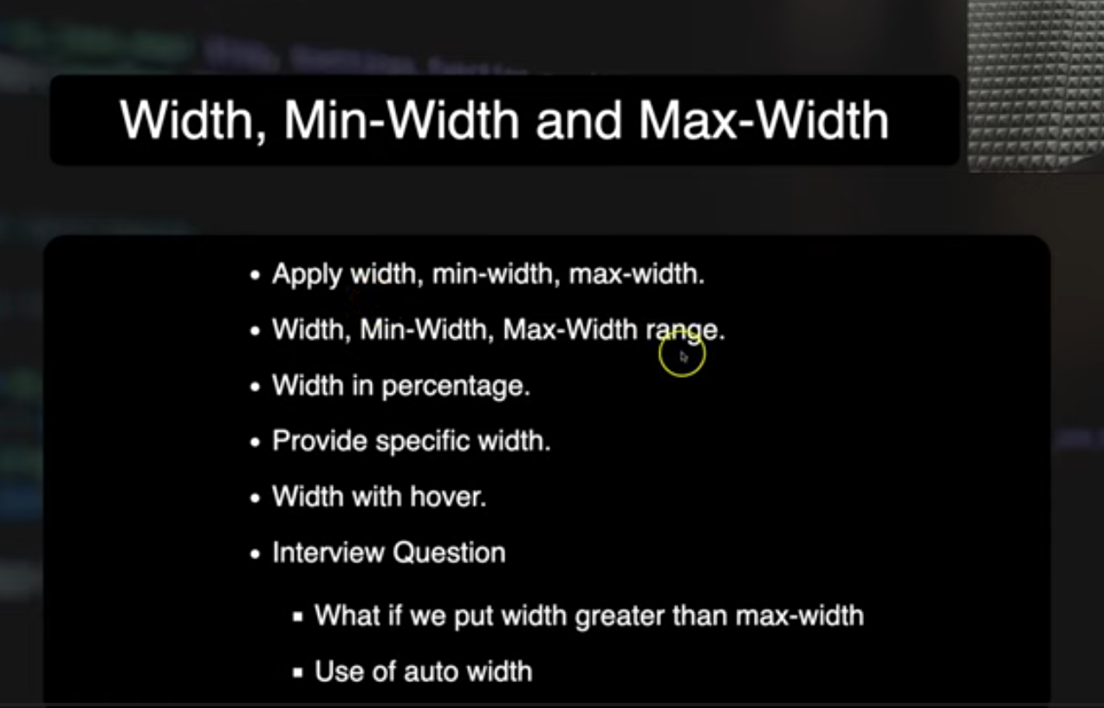

width --->

<h1 class="bg-pink-300 w-50">CODE STEP BY STEP</h1>

max-width and min-width

<h1 class="bg-pink-200 max-w-50 w-90">CODE STEP BY STEP</h1>
<h1 class="bg-pink-200 min-w-100 w-90">CODE STEP BY STEP</h1>

there is no limitation of range

w-full --> complete width
w-1/2--> half width(50%) 1/3 means 33% so on

xs-- 350px
xl—576px

and there are lot you can explore on talwind css documentation

to apply specific width --- w-[10px];

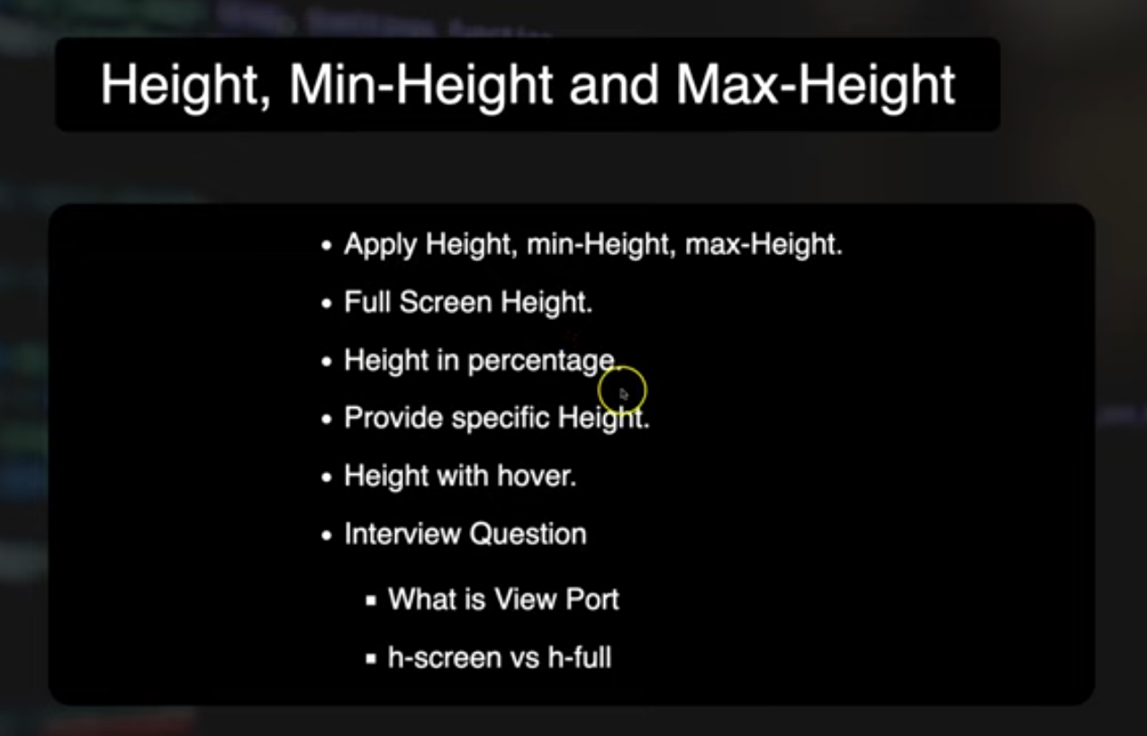

height -->

<div class="bg-green-200 h-30">code step by step </div>

to give full height

<body class="h-screen">

<div class="bg-green-200 h-full">code step by step </div>

</body>

to give half height

<div class="bg-green-200 h-1/2">code step by step </div>

dynamic view port

<div class="bg-green-200 h-dvw" >code step by step</div>

for min and max width

max-h-50
min-h-10

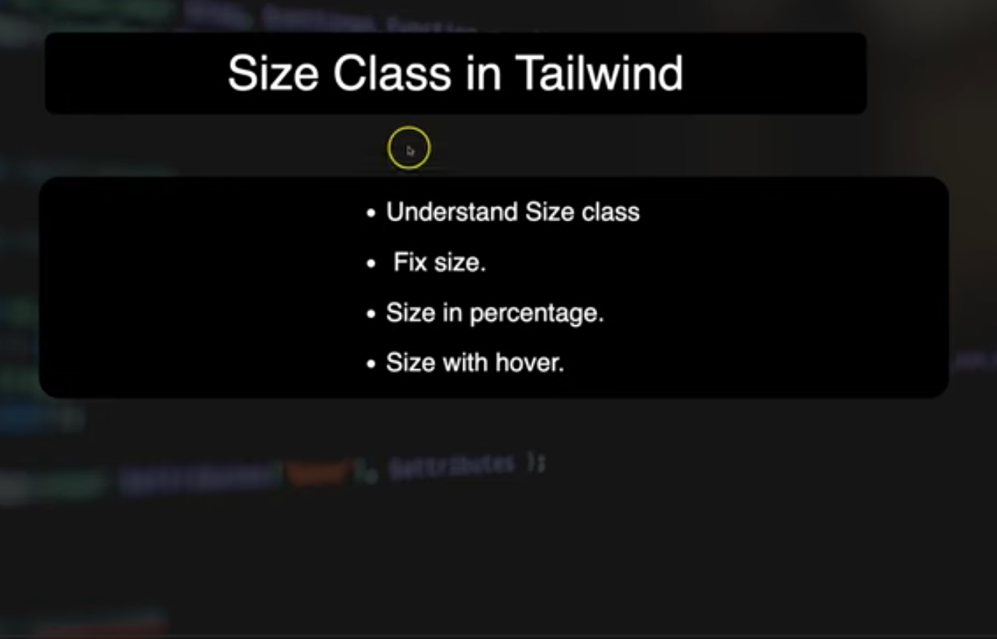

the place where you want to use same ht and width you can use size

<!-- <div class="w-50 h-50 bg-amber-400">code step by step </div> -->

<div class="size-50 bg-amber-400">code step by step </div>

both are same

minsize and maxsize not work with size instead of this all work ht and width property work

<body class="h-screen">

<div class="bg-green-200 size-1/2">code step by step </div>
<div class="bg-green-200 size-fit">code step by step </div>
<div class="bg-green-200 size-full">code step by step </div>
<div class="bg-green-200 size-[3px]">code step by step </div>

</body
</body
</body
</body>

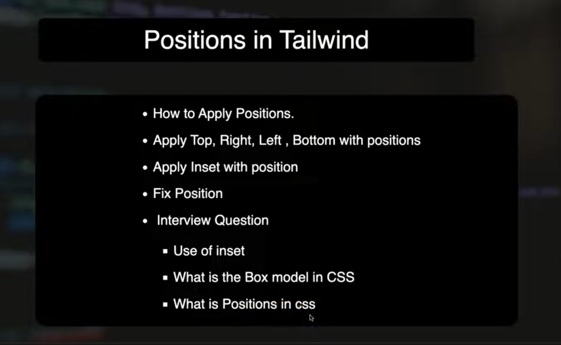

<!DOCTYPE html>
<html lang="en">
<head>
<meta charset="UTF-8">
<meta name="viewport" content="width=device-width, initial-scale=1.0">
<title>POSITION</title>
<link href="./output.css" rel="stylesheet">
</head>
<body>

<div class="bg-red-500 size-96 relative">

<div class="bg-red-200 size-12 absolute bottom-0 right-0 ">
</div>
<div class="bg-green-200 size-12 absolute top-0 right-0 ">
</div>

<div class="bg-blue-200 size-12 absolute bottom-0 left-0">
</div>
<div class="bg-yellow-200 size-12 absolute top-0 left-0">
</div>

</div>

<br>

<div class="bg-blue-500 size-96">

<h1 class="bg-blue-950 text-white fixed z-300">code step by step </h1>

</div>

<div class="bg-green-500 size-96 relative">

<div class="bg-green-900 size-32 inset-32 absolute "></div>
<!-- inset give space from all direction -->

</div>

</body>
</html>

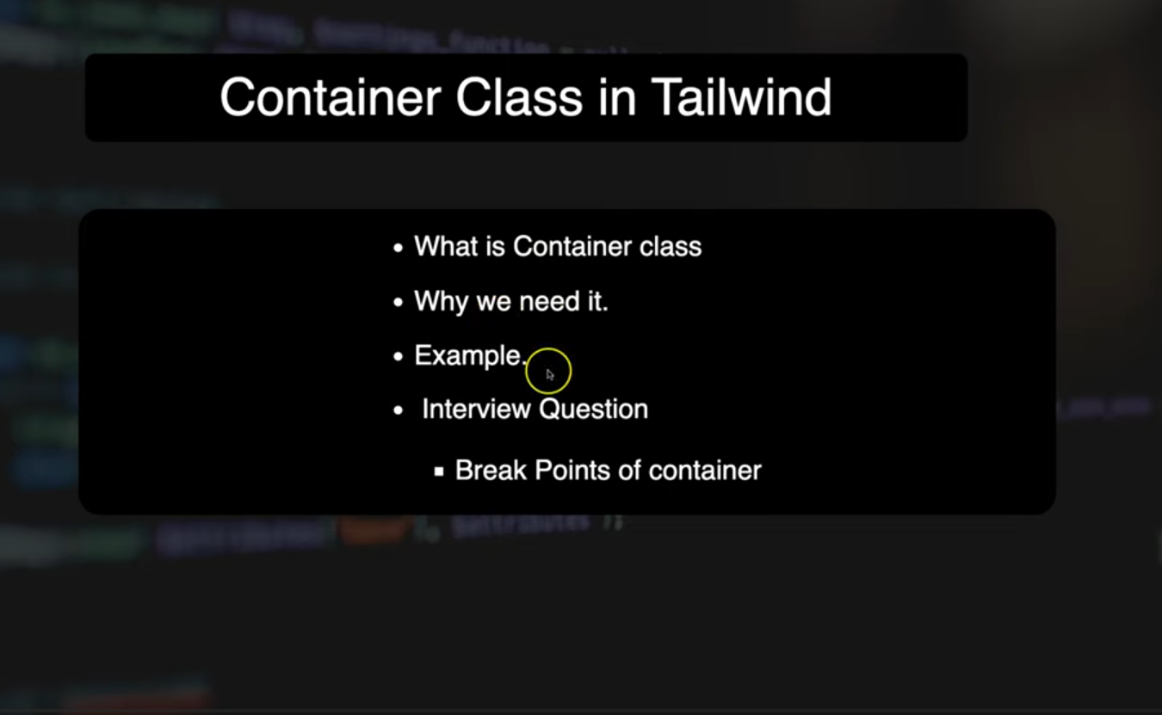
<!DOCTYPE html>
<html lang="en">
<head>
<meta charset="UTF-8">
<meta name="viewport" content="width=device-width, initial-scale=1.0">
<title>CONTAINER</title>
<link href="./output.css" rel="stylesheet">
</head>
<body>

<div class="bg-amber-700">

<ul class="flex justify-end [&>*]:p-4">
<li><a href="">HOME</a></li>
<li><a href="">ABOUT</a></li>
<li><a href="">CONTACT</a></li>
<li><a href="">LOGIN</a></li>
</ul>

</div>

<div class="text-8xl bg-amber-500 container mx-auto">

Container class

</div>

<div class="text-7xl bg-amber-400 container mx-auto">

Main page

</div>

<div class="text-6xl bg-amber-300 container mx-auto">

Down Page

</div>

</body>
</html>

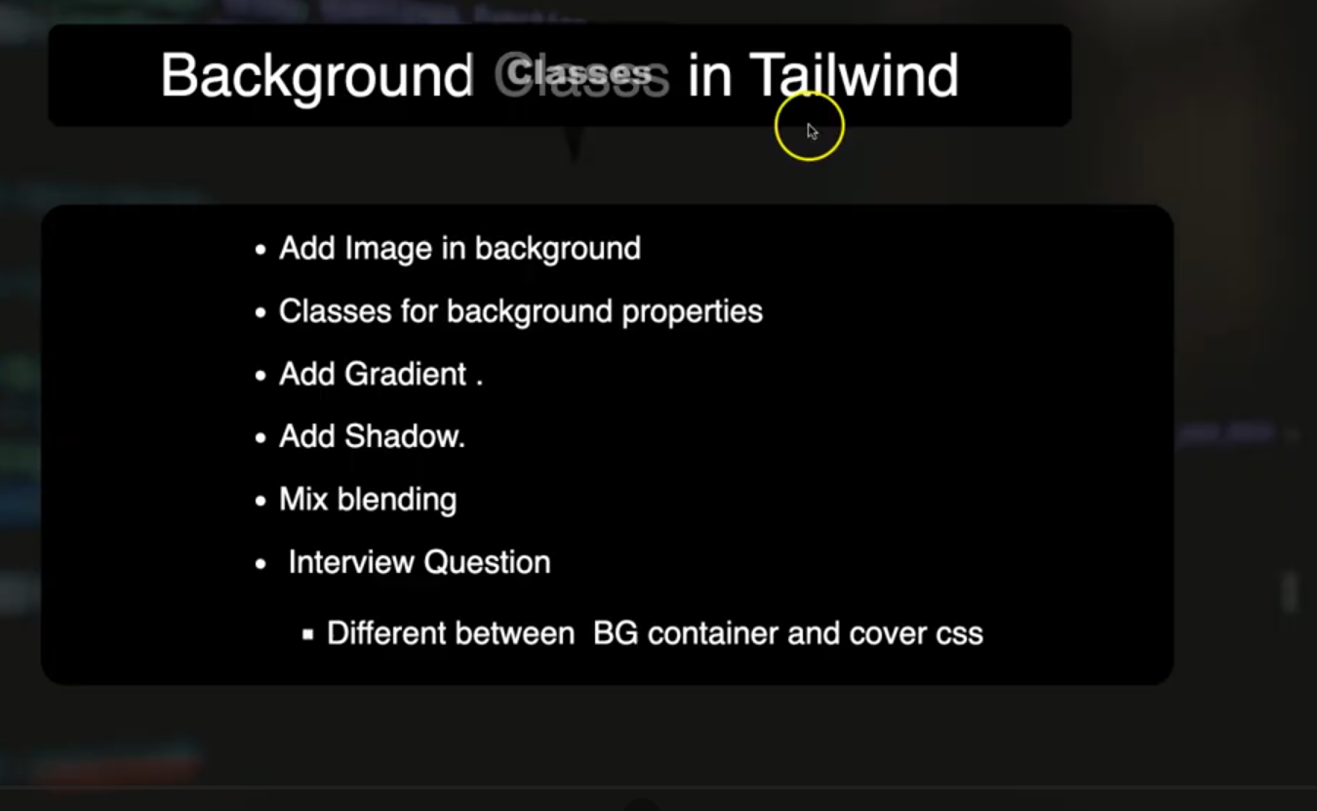
<!doctype html>
<html>
<head>
<meta charset="UTF-8">
<meta name="viewport" content="width=device-width, initial-scale=1.0">
<link href="./output.css" rel="stylesheet">
<title>BACKGROUND CLASSES</title>
</head>

<body >

<div class="bg-red-500 h-96 bg-[url(MOKEY.jpg)] bg-no-repeat bg-center bg-container ">

HELLO TALWIND
</div>

<!-- gradient -->
<div class="gradient bg-gradient-to-t to-blue-500 from-red-500 size-96">

</div>

<div class="gradient bg-gradient-to-l to-blue-500 from-red-500 size-96">

</div>

<div class="gradient bg-gradient-to-tr to-yellow-500 from-blue-500 size-96">

</div>

<!-- shadow -->

<div class="size-96 m-32 shadow-orange-400 shadow-2xl"></div>

<div class="size-96 m-32 shadow-orange shadow-inner shadow-orange-400"></div>

</body>

</html>

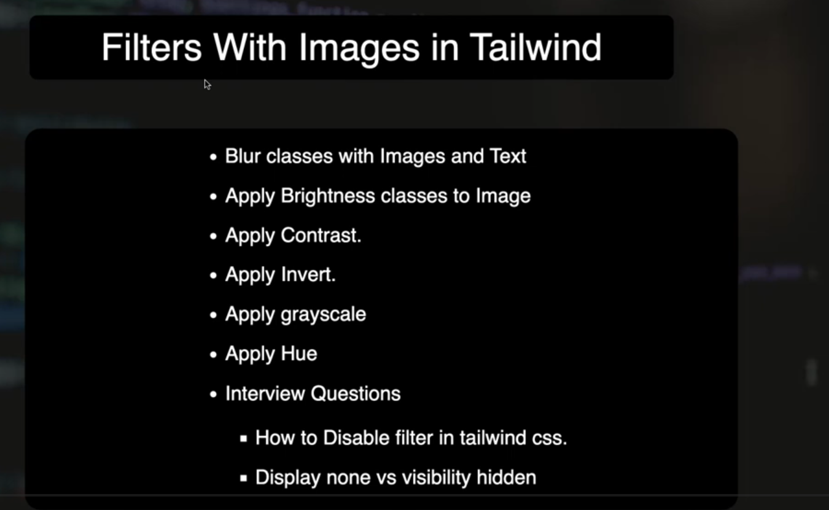
<!DOCTYPE html>
<html lang="en">
<head>
<meta charset="UTF-8">
<meta name="viewport" content="width=device-width, initial-scale=1.0">
<title>FILTER</title>
<link href="./output.css" rel="stylesheet">
</head>
<body>
<!-- blur the text -->

<!-- <h1 class="blur-sm">Blur image </h1> -->

<!-- blur image -->
<!-- <img src="MOKEY.jpg" class="size-96 blur-sm">
<img src="MOKEY.jpg" class="size-96 blur-md">
<img src="MOKEY.jpg" class="size-96 blur-3xl"> -->

<!-- brightness of image -->

<!-- <img src="MOKEY.jpg" class="size-96 brightness-50">
<img src="MOKEY.jpg" class="size-96 brightness-100">
<img src="MOKEY.jpg" class="size-96 brightness-125">
<img src="MOKEY.jpg" class="size-96 brightness-250">
-->

<!-- contrast handle -->

<!-- <h1> CONTRAST</h1>

<img src="MOKEY.jpg" class="size-96 contrast-0 ">
<img src="MOKEY.jpg" class="size-96 contrast-50">
<img src="MOKEY.jpg" class="size-96 contrast-100">
<img src="MOKEY.jpg" class="size-96 contrast-125">

-->

<!-- grayScale -->

<!-- <img src="MOKEY.jpg" class="size-96 grayscale ">
<img src="MOKEY.jpg" class="size-96 contrast-50">
-->

<!-- invert -->

<!-- <img src="MOKEY.jpg" class="size-96 invert ">
<img src="MOKEY.jpg" class="size-96 ">
-->

<!-- hue -->

<!-- invert -->

<img src="MOKEY.jpg" class="size-96 hue-rotate-15 ">
<img src="MOKEY.jpg" class="size-96 hue-rotate-60 ">
<img src="MOKEY.jpg" class="size-96 hue-rotate-90 ">
<img src="MOKEY.jpg" class="size-96 hue-rotate-180 ">

</body>
</html>

how to disable filters?
Ans--> corePlugins:{
filter:false
}

apply this in talwind config.js

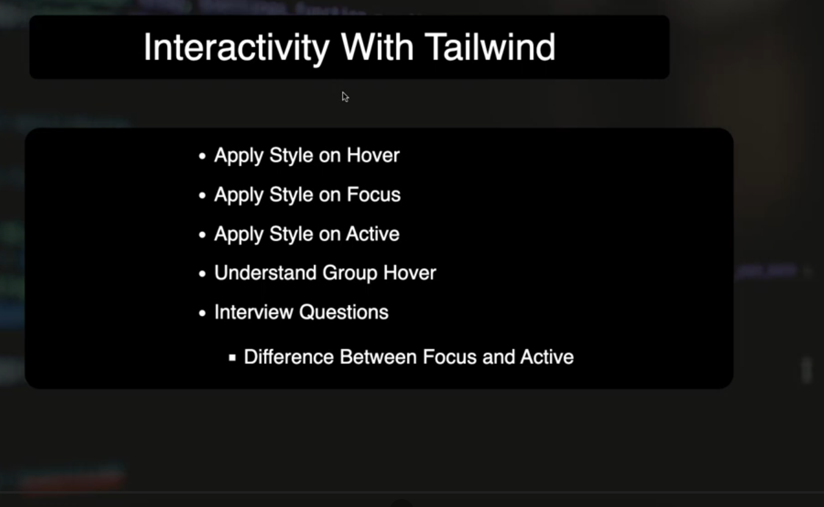
interactivty means --> let’s say you perfom some event on ui and ui response it that is called interactivey ex-- hover,focus,active

<button type="button" class="bg-blue-500 rounded-md p-2 m-4 text-white">LOGIN</button>
<button type="button" class="bg-blue-500 rounded-md p-2 m-4 text-white hover:bg-blue-800">LOGIN</button>
<button type="button" class="bg-blue-500 rounded-md p-2 m-4 text-white hover:bg-blue-800 hover:p-10">LOGIN</button>
<button type="button" class="bg-blue-500 rounded-md p-2 m-4 text-white focus:bg-yellow-600 ">LOGIN</button>

<button type="button" class="bg-blue-500 rounded-md p-2 m-4 text-white active:bg-red-600 ">LOGIN</button>

focus-- click on element then it will come , when you click outside of element it will remove
active-- jab tak element pai click krke rakhoge taab tak hi rahega

<!-- all this 3 in one -->

<button type="button" class="bg-blue-500 rounded-md p-2 m-4 text-white active:bg-red-600 hover:bg-yellow-600 focus:bg-green-600">LOGIN</button>

<!-- group hover -->

<div class="group">

<a >click me

<h1 class="group-hover:text-blue-500 group-hover:bg-red-500">Heading click</h1>
<p class="group-hover:text-blue-500 group-hover:bg-white">para click</p>
</a>

</div>

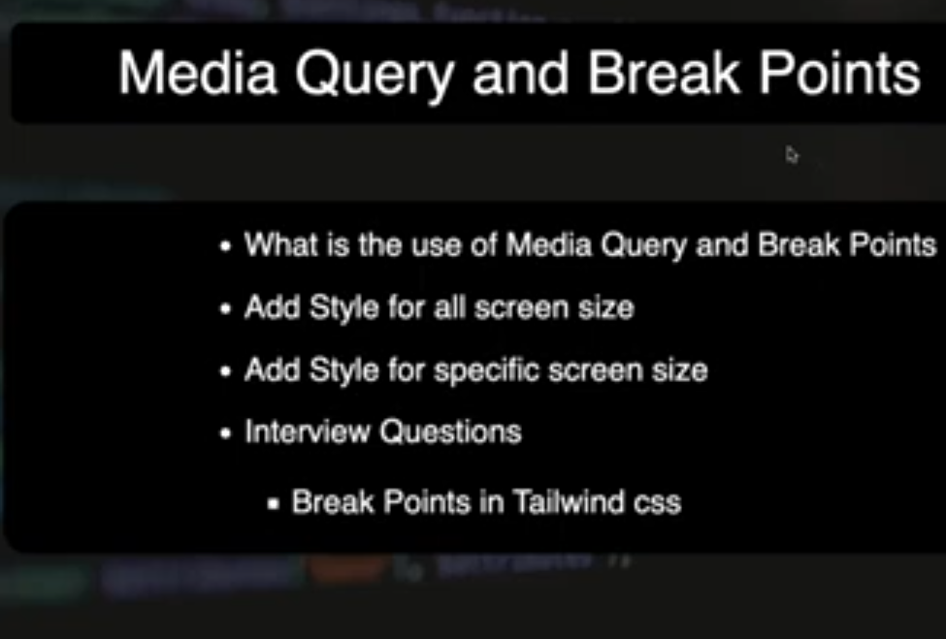
. breakpoint is a feature that allow us to apply diffrent-diffrent style for diffrent width.
In talwind css, it is not necessary to write media query explicitly , we can use breakpoints

<body class="h-screen">

<div class="bg-red-500 h-full
lg:bg-green-500
md:bg-blue-500
sm:bg-gray-500">
<h1 class="text-4xl 2xl:text-8xl"> MICROSOFT</h1>
</div>

</body>

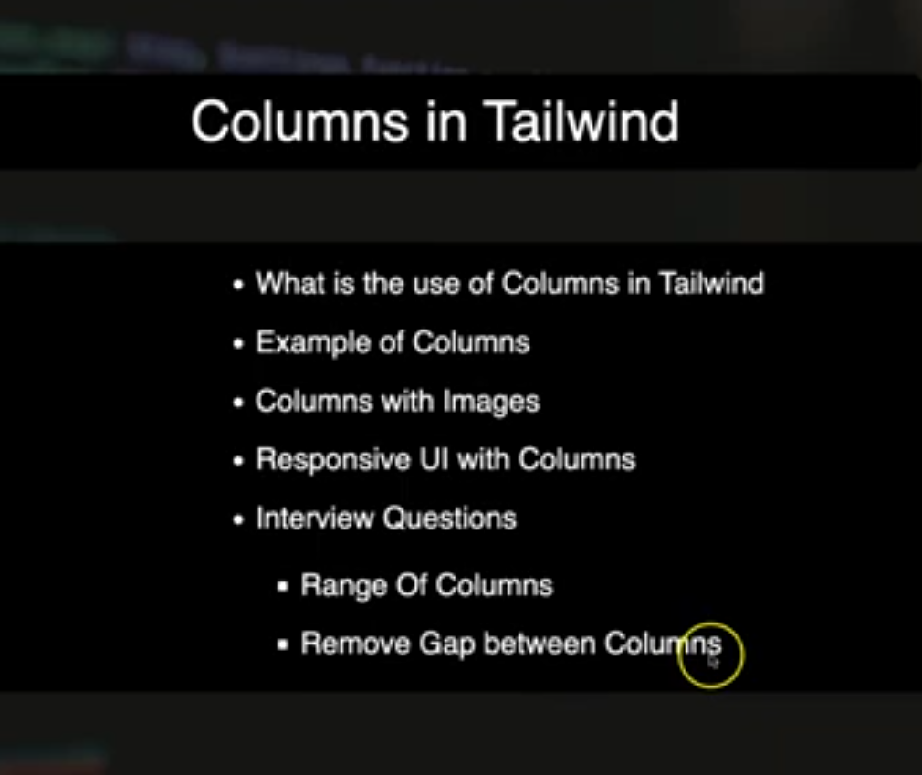
by using column you can divide you ui into equal parts.0
<div class="columns-2 gap-0">
<h1 class="columns-2 bg-red-500 size-32 text-center">Heading 1</h1>
<h1 class="columns-2 bg-green-500 size-32 text-center">Heading 2</h1>
<h1 class="columns-2 bg-red-500 size-32 text-center">Heading 3</h1>
<h1 class="columns-2 bg-green-500 size-32 text-center">Heading 4</h1>
</div>

<div class="bg-gray-200 size-full flex justify-around items-center">

<div class="bg-red-300 size-20"></div>
<div class="bg-blue-300 size-20"></div>
<div class="bg-yellow-400 size-20"></div>
<div class="bg-green-300 size-20"></div>

</div>

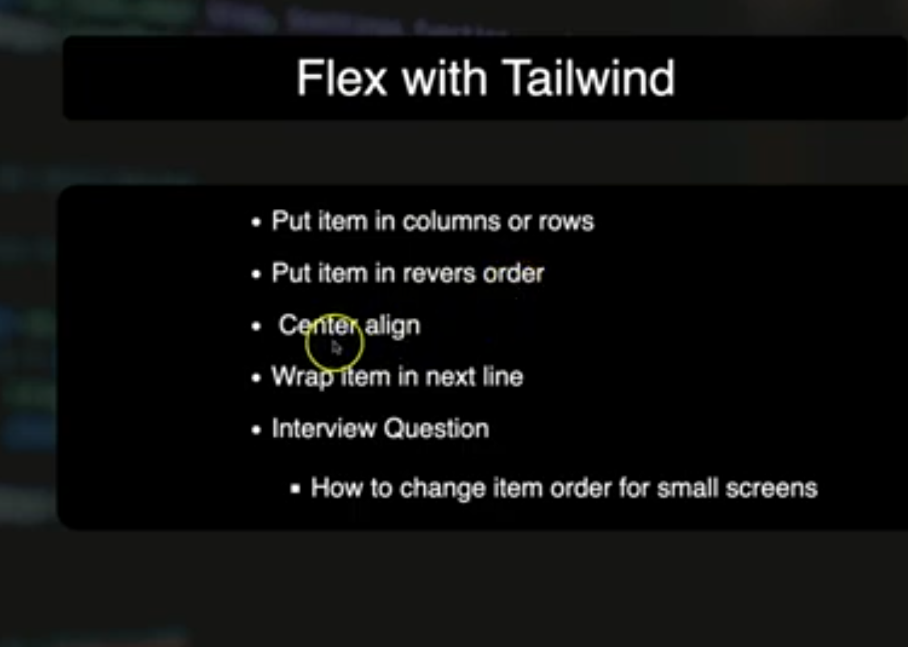

<div class="bg-gray-200 size-full flex justify-around items-center">

<div class="bg-red-300 size-20"></div>
<div class="bg-blue-300 size-20"></div>
<div class="bg-yellow-400 size-20"></div>
<div class="bg-green-300 size-20"></div>

</div>

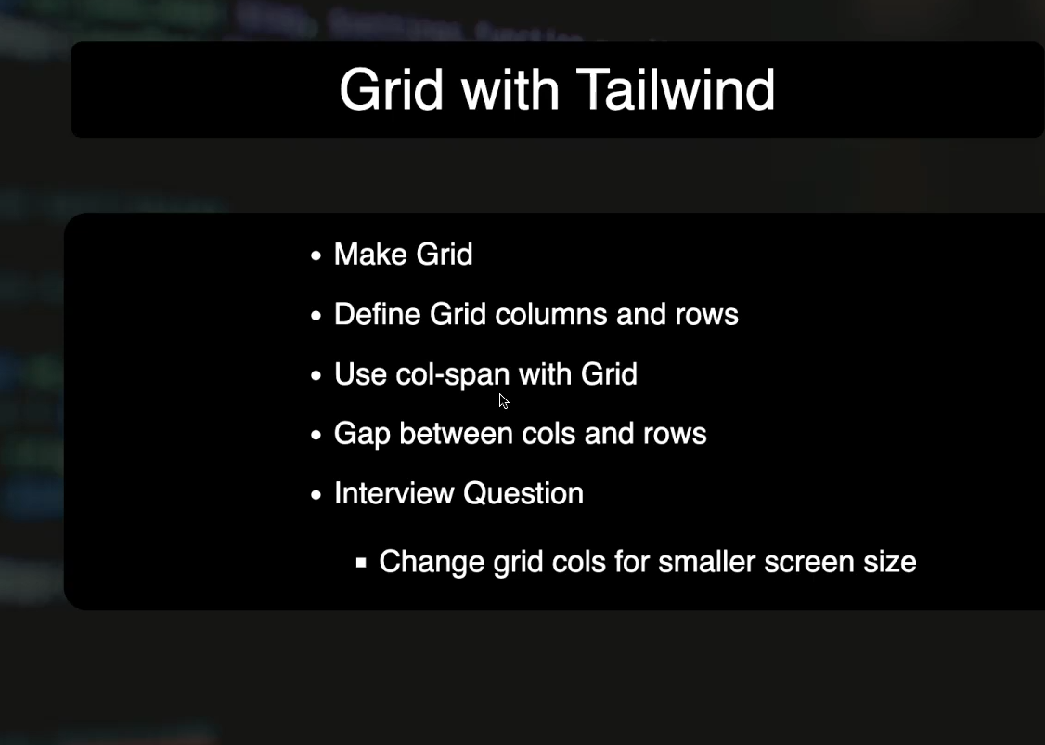
fzsadffs

<div class="grid grid-cols-4 gap-2">
<div class="bg-red-300 p-10 border border-red-700 col-span-4"></div>
<div class="bg-red-300 p-10 border border-red-700 row-span-2"></div>
<div class="bg-red-300 p-10 border border-red-700"></div>
<div class="bg-red-300 p-10 border border-red-700"></div>
<div class="bg-red-300 p-10 border border-red-700 col-span-4"></div>
<div class="bg-red-300 p-10 border border-red-700"></div>
<div class="bg-red-300 p-10 border border-red-700"></div>
<div class="bg-red-300 p-10 border border-red-700"></div>
<div class="bg-red-300 p-10 border border-red-700"></div>
<div class="bg-red-300 p-10 border border-red-700"></div>
<div class="bg-red-300 p-10 border border-red-700"></div>
<div class="bg-red-300 p-10 border border-red-700"></div>
<div class="bg-red-300 p-10 border border-red-700"></div>
<div class="bg-red-300 p-10 border border-red-700"></div>
<div class="bg-red-300 p-10 border border-red-700"></div>
<div class="bg-red-300 p-10 border border-red-700"></div>

</div>

row-span-- how may row one box take
col-span-- how many column one box take

gap---> gap between rows and columns

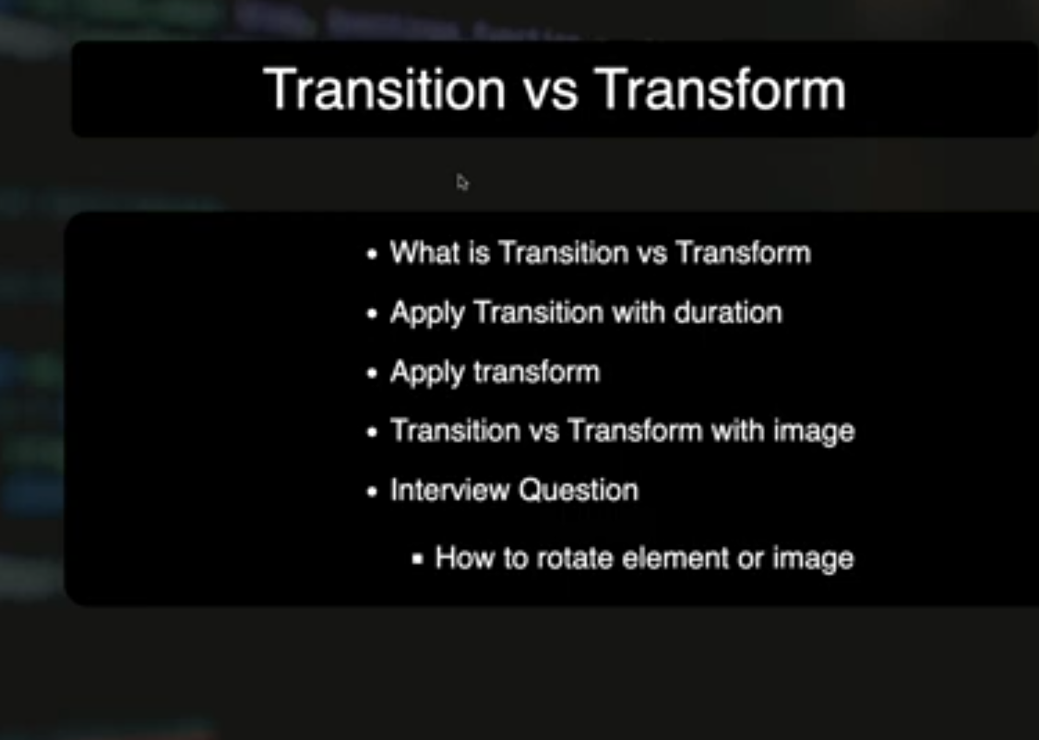
trans

<!-- <button class="bg-blue-500 p-2 m-10 text-white rounded hover:bg-blue-950">Login</button>
<button class="bg-blue-500 p-2 m-10 text-white rounded
hover:bg-blue-950 transition duration-1000
">Signup</button>
-->

<button class="bg-blue-500 p-2 m-10 text-white rounded hover:opacity-5 transition duration-1000 ">Button-1</button>
<button class="bg-blue-500 p-2 m-10 text-white rounded hover:bg-blue-950 transition duration-1000">Button-2</button>
<button class="bg-blue-500 p-2 m-10 text-white rounded hover:bg-blue-950 transition duration-1000">Button-3</button>
<button class="bg-red-500 p-2 m-10 text-white rounded hover:rotate-180 transition-transform duration-1000">Button-3</button>
<button class="bg-red-500 p-2 m-10 text-white rounded hover:scale-75 transition-transform duration-1000">Button-3</button>
<button class="bg-red-500 p-2 m-10 text-white rounded hover:scale-x-175 hover:scale-y-175 transition-transform duration-1000">Button-3</button>

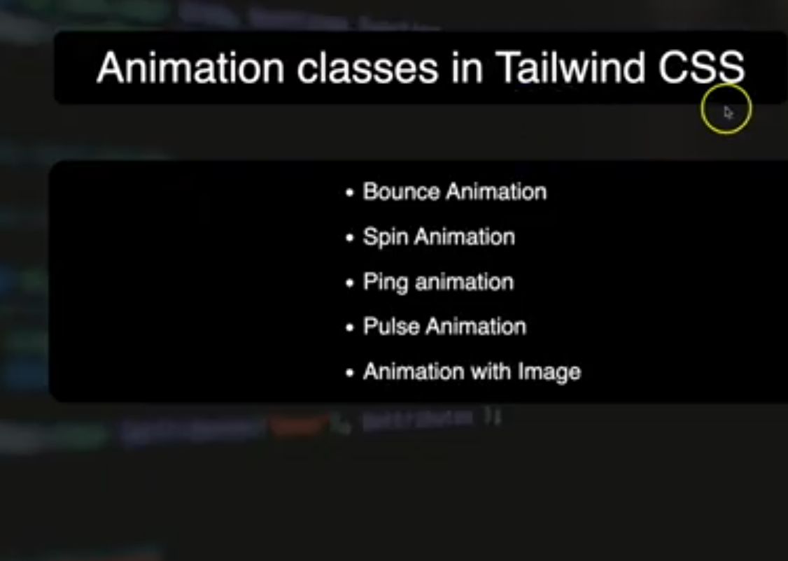
kjldafs

<!DOCTYPE html>
<html lang="en">
<head>
<meta charset="UTF-8">
<meta name="viewport" content="width=device-width, initial-scale=1.0">
<title>Animation</title>
<link href="./output.css" rel="stylesheet">
</head>
<body>
<div class="size-20 bg-red-600 mt-10 ml-10 rounded-full animate-bounce">
</div>
<hr>

<div class="w-32 h-2 bg-red-600 mt-32 ml-32 animate-spin">
</div>
<hr>

<div class="size-20 bg-red-600 m-52 rounded-full animate-ping">
</div>

<div class="size-20 bg-red-600 m-52 rounded-full animate-pulse">
</div>

</body>
</html>

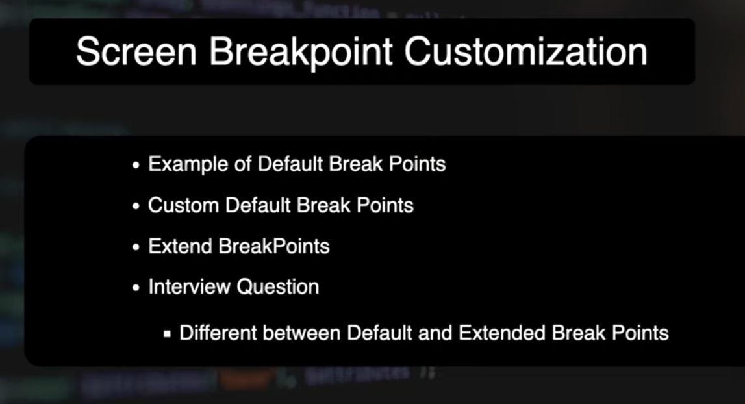

<div class="bg-pink-400 text-4xl sm:bg-red-900 big:bg-gray-700">

Hello Talwind 4

</div>

​for making custom break or defaul breakpoints mai kuch chnage krna ho to use this @theme

@theme{
--breakpoint-sm:400px; /* customize kr dia default brekapoint ab ye 400 se start hoga*/
--breakpoint-big:1300px /* khud ka new breakpoint banaya */
}

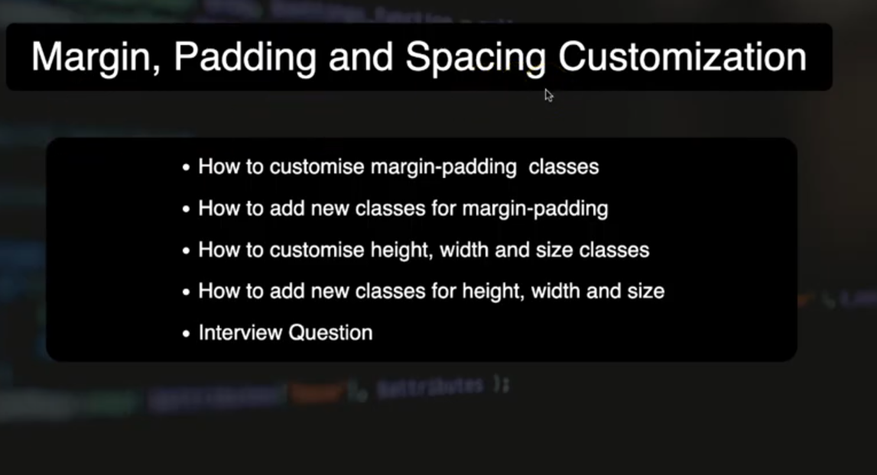
kjk

see index.css and file related to it

